**Blueprint Reading Notes:**

Blueprints (prints) are copies of mechanical or other types of technical drawings. The term blueprint reading, means interpreting ideas expressed by others on drawings, whether or not the drawings are actually blueprints. Blueprints show the construction details of parts, machines, ships, aircraft, buildings, bridges, roads, and so forth.

The standards and procedures prescribed for military drawings and blueprints are stated in military standards (MIL-STD) and American National Standards Institute (ANSI) standards.

Military Standard and American Nation Standards Institute common standards are shown below:

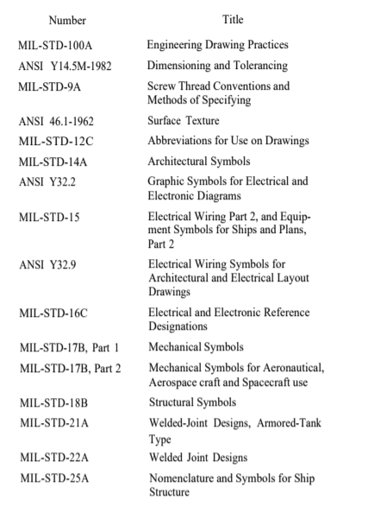

Some general parts of blueprints include information blocks, finish marks, notes, specifications, legends, and symbols.

The draftsman uses information blocks to give the reader additional information about materials, specifications, and so forth that are not shown in the blueprint or that may need additional explanation.

A basic layout for many blueprints is demonstrated below:

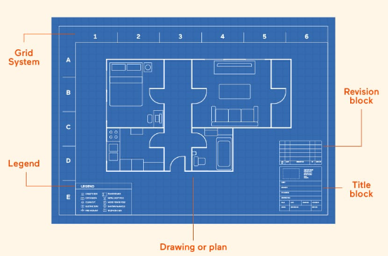

A grid system in a blueprint is a network of horizontal and vertical lines that divide the drawing area into squares or rectangles, providing a precise coordinate system for design elements. It helps create accurate drawings, measure and scale designs, and align elements with ease. The grid consists of grid lines, squares or modules, and coordinates that enable precise location and communication among designers, making it a fundamental tool in architecture, engineering, and design.

A legend in a blueprint is a key that explains the symbols, abbreviations, and conventions used in the drawing, ensuring clear communication and understanding of the design. It provides a reference guide for the various elements and notations, defining graphical symbols, abbreviations, and drawing conventions, and often includes additional notes and explanations. Located in a corner of the blueprint, the legend is an essential component that helps architects, engineers, and builders accurately interpret and execute the design.

The title block is often located in the lower-right corner of all blueprints and drawings. It contains the drawing number, name of the part or assembly that it represents, and all information required to identify the part or assembly.

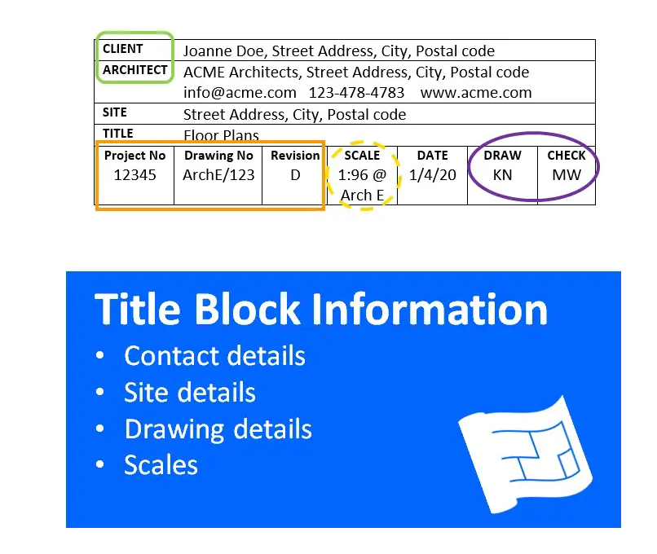

A space within the title block with a diagonal or slant line drawn across it shows that the information is not required or is given elsewhere on the drawing.

Revision blocks: a dedicated section that tracks changes and updates made to the design. It includes essential information such as revision number, date, description of changes, and approval details. This block provides a record of modifications, ensuring accuracy and accountability in architectural, engineering, and construction drawings. These are frequently found in the upper right corner of a blueprint.

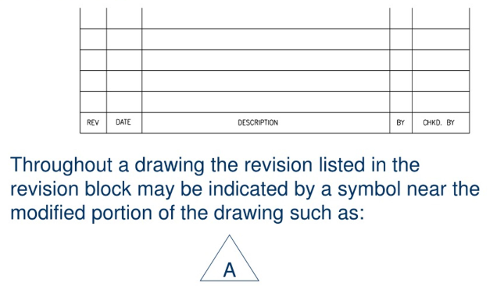

When a blueprint is revised, the letter A in the revision block is replaced by the letter B and so forth.

Reference numbers that appear in the title block refer to numbers of other blueprints. A dash and a number show that more than one detail is shown on a drawing. When two parts are shown in one detail drawing, the print will have the drawing number plus a dash and an individual number.

In addition to appearing in the title block, the dash and number may appear on the face of the drawings near the parts they identify. A dash and number identify changed or improved parts and right-hand and left-hand parts.

On some prints you may see a notation above the title block such as “159674 LH shown; 159674-1 RH opposite.” Both parts carry the same number. LH means left hand, and RH means right hand. Some companies use odd numbers for right-hand parts and even numbers for left-hand parts.

Zone numbers serve the same purpose as the numbers and letters printed on borders of maps to help you locate a particular point or part.

The scale block in the title block of the blueprint shows the size of the drawing compared with the actual size of the part. The scale is chosen to fit the object being drawn and space available on a sheet of drawing paper.

Never measure a drawing; use dimensions. The print may have been reduced in size from the original drawing. Read the dimensions on the drawing; they always remain the same.

The bill of material block contains a list of the parts and/or material needed for the project. The block identifies parts and materials by stock number or other appropriate number, and lists the quantities requited.

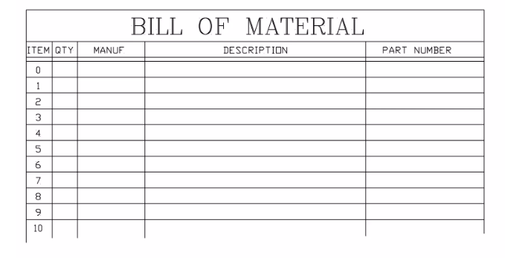

The application block on a blueprint tells you where the part or assembly shown fits into a bigger machine or system. It points out what larger unit the part belongs to.

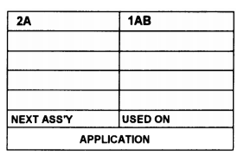

Finish marks- checkmarks- are used on machine drawings show surfaces to be finished by machining. Machining provides a better surface appearance and a better fit with closely mated parts.

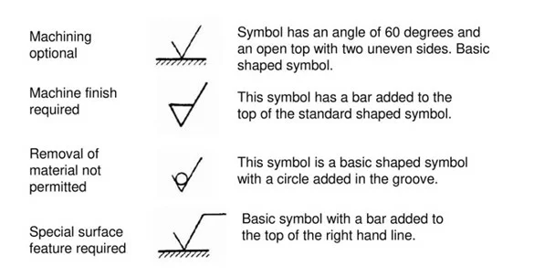

Notes are placed on drawings to give additional information to clarify the object on the blueprint.



A specification is a statement or document containing a description such as the terms of a contract or details of an object or objects not shown on a blueprint or drawing.

The legend explains or defines a symbol or special mark placed on the blueprint.

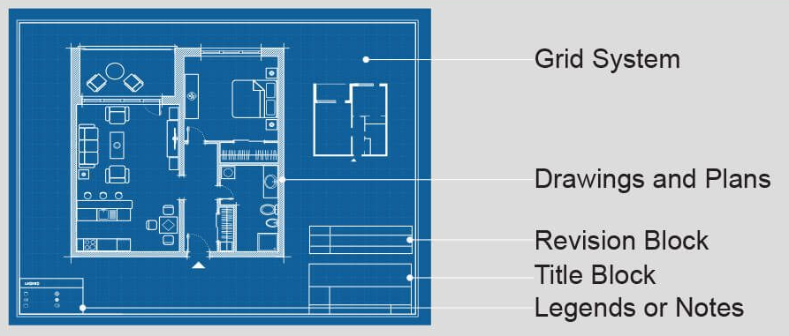

Lines in blueprints, also known as engineering drawings, are a visual language that convey important information about the design, dimensions, and features of a structure or component. Different types of lines are used to distinguish between elements, enhance clarity, and convey specific information.

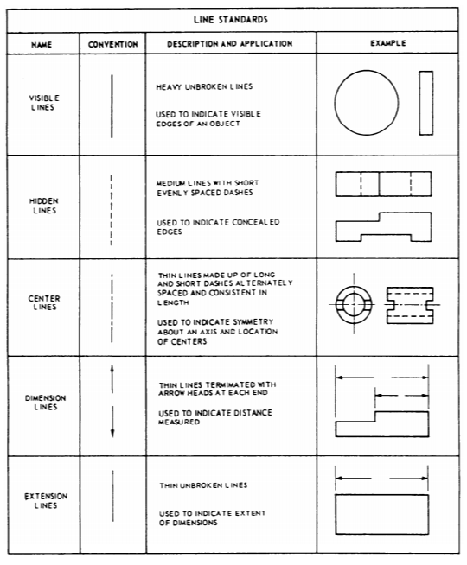

Preliminary plans are submitted with bids or other plans before a contract is awarded.

Contract plans illustrate mandatory design features of a ship.

Contract guidance plans illustrate design features of a ship subject to development.

Standard plans illustrate arrangement or details of equipment, systems, or parts where specific requirements are mandatory.

Type plans illustrate the general arrangement of equipment, systems, or parts that do not require strict compliance to details as long as the work gets the required results.

Working plans are those the contractor uses to construct a ship.

Corrected plans are those that have been corrected to illustrate a final ship and system arrangement, fabrication, and installation.

Onboard plans are those considered necessary as reference materials in the operation of a ship.

An SPI (ship’s plan index) lists all plans that apply to a ship except those for certain miscellaneous items covered by standard or type plans.

Blueprints can be fragile documents. Some simple tips to care for them include:

* Keep them out of sunlight to prevent fading
* Try to keep them from grease or other types of chemical smudging
* Don’t make pencil or other notations without authority from proper personnel
* Keep them stored away just as they were received to prevent tearing or folding

Below is a list of common line types in blueprints. Some were already discussed, but this is a more extensive list.

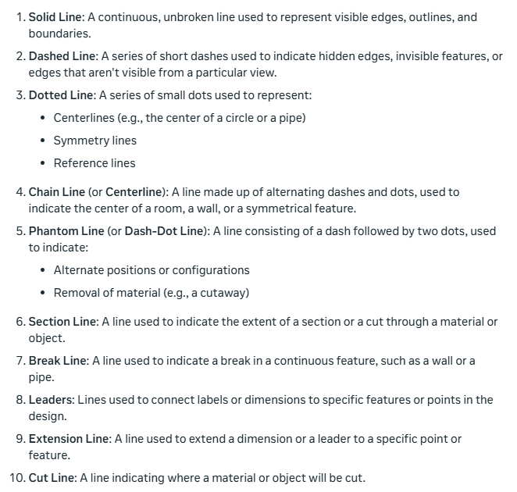

By integrating CAD and CNC, designers and manufacturers can produce high-quality parts with increased efficiency and accuracy, reducing the time and cost associated with traditional manufacturing methods.

The process of preparing engineering drawings on a computer is known as computer-aided drafting (CAD).

A CNC (Computer Numerical Control) machine is a computer-controlled manufacturing device that uses programming language to execute precise movements and actions, such as cutting, drilling, or shaping, on various materials like metal, wood, or plastic.

Computer-generated instructions can be stored in a central computer’s memory, or on a disk, for direct transfer to one or more CNC machine tools that will make the parts. This is known as direct numerical control (DNC).

CAM (Computer-Aided Manufacturing) is software used to control machine tools and manufacturing processes by taking a CAD instruction and converting it to machine-readable instructions (G-code).

CAD/CAM stands for Computer-Aided Design (CAD) and Computer-Aided Manufacturing (CAM). It's a combination of two technologies that work together to streamline the design-to-manufacturing process.

In blueprint reading, a view of an object is known technically as a projection. Projection is done, in theory, by extending lines of sight called projectors from the eye of the observer through lines and points on the object to the plane of projection.

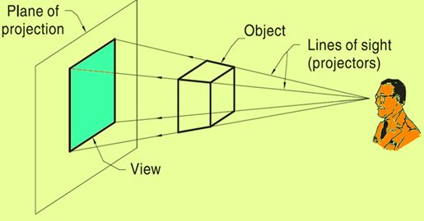

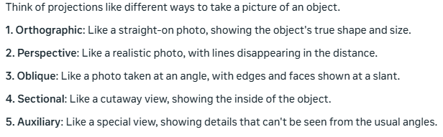

A perspective drawing is the most used method of presentation used in technical illustrations in the commercial and architectural fields. The drawn objects appear proportionately smaller with distance, as they do when you look at the real object.

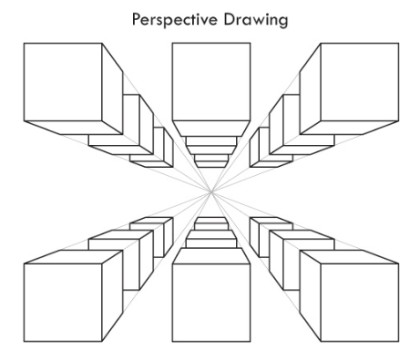

Auxiliary views are often necessary to show the true shape and length of inclined surfaces, or other features that are not parallel to the principal planes of projection.

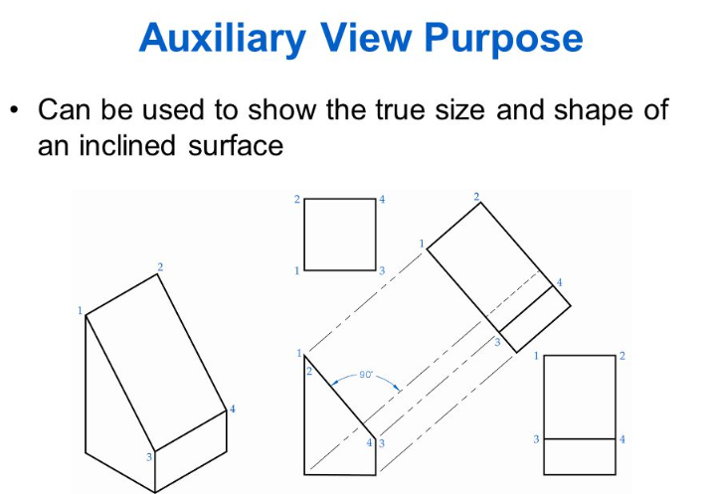

Section views give a clearer view of the interior or hidden features of an object that you normally cannot see clearly in other views. A section view is made by visually cutting away a part of an object to show the shape and construction at the cutting plane. When sectional views are drawn, the part that is cut by the cutting plane is marked with diagonal (or crosshatched), parallel section lines.

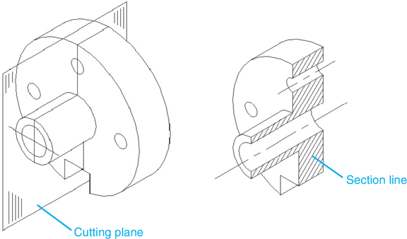

In blueprints, an offset section is a type of view that shows a portion of the building or object at an angle, usually to clarify the relationship between different parts of the structure.

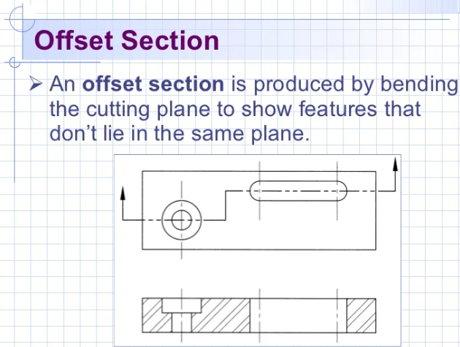

Half section—This type of section is used when an object is symmetrical in both outside and inside details. One-half of the object is sectioned; the other half is shown as a standard view.

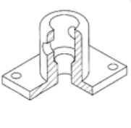

Revolved section—This type of section is used to eliminate the need to draw extra views of rolled shapes, ribs, and similar forms. It is really a drawing within a drawing, and it clearly describes the object’s shape at a certain cross section.

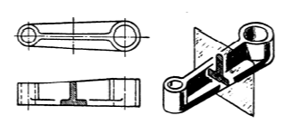

Removed section—This type of section is used to illustrate particular parts of an object. It is drawn like the revolved section, except it is placed at one side to bring out important details.

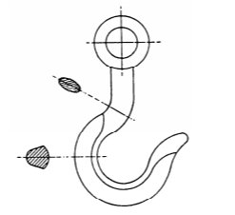

Broken-out section—The inner structure of a small area may be shown by peeling back or removing the outside surface.

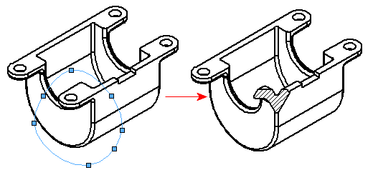

An aligned section in blueprints shows angled parts as if they were cut and rotated to face the viewer directly. This makes it easier to see the real shape and size of complex features that aren't straight up-and-down or side-to-side in the main drawing.

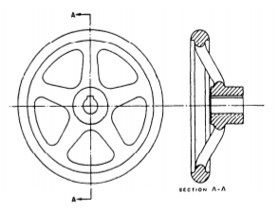

An exploded view in blueprint reading is a diagram that shows all the parts of an object separated but in the correct order. It's like the object has been pulled apart in mid-air, with the pieces floating in their relative positions. This type of view helps show how different parts fit together and makes it easier to understand the assembly process.

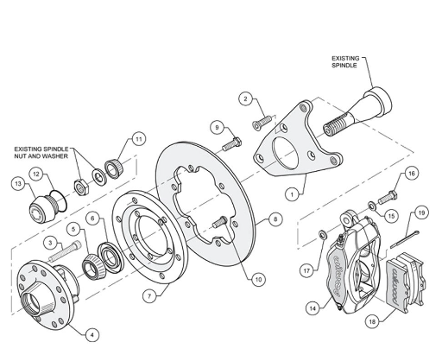

A detail drawing is a print that shows a single component or part. It includes a complete and exact description of the part’s shape and dimensions, and how it is made. A complete detail drawing will show in a direct and simple manner the shape, exact size, type of material, finish for each part, tolerance, necessary shop operations, number of parts required, and so forth.

In learning to read machine drawings, you must first become familiar with the common terms, symbols, and conventions.

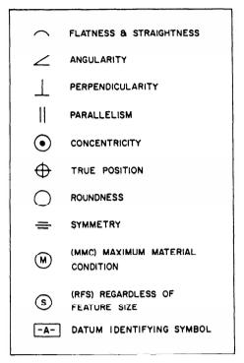

Tolerances: A tolerance in engineering is the acceptable range of variation for a dimension or measurement. It defines how much a part can deviate from its ideal size or shape while still being considered functional and acceptable.

Fillets are smooth, curved inside corners in metal parts. They make cast metal stronger by helping it cool evenly. This reduces the chance of breaks. Rounds (or radii) are smooth, curved outside corners. They prevent chipping and remove sharp edges. Both fillets and rounds replace sharp angles with gentle curves, but fillets are on the inside and rounds are on the outside.

Slots and slides are used to mate two specially shaped pieces of material and securely hold them together, yet allow them to move or slide.

Keys, keyways, and keysets are used to join rotating parts in machines. A key is a small metal piece that fits into matching slots (keyways) in a shaft and the part it drives. This prevents the parts from spinning separately. The whole assembly is called a keyset. It's a simple way to transfer rotational motion between parts.

Thread classes used to be called "class of fit." The National Bureau of Standards changed the name to "class of thread" in their official standards. However, people will likely keep using the old term "class of fit" for a long time.

Helix-The curve formed on any cylinder by a straight line in a plane that is wrapped around the cylinder with a forward progression.

External Thread-A thread on the outside of a member. An example is the thread of a bolt.

Internal Thread-A thread on the inside of a member. An example is the thread inside a nut.

Major Diameter-The largest diameter of an external or internal thread.

Axis-The center line running lengthwise through a screw.

Crest-The surface of the thread corresponding to the major diameter of an external thread and the minor diameter of an internal thread.

Root-The surface of the thread corresponding to the minor diameter of an external thread and the diameter of an internal thread.

Depth-The distance from the root of a thread to the crest, measured perpendicularly to the axis.

Pitch-The distance from a point on a screw thread to a corresponding point on the next thread, measured parallel to the axis.

Lead-The distance a screw thread advances on one turn, measured parallel to the axis. On a single-thread screw the lead and the pitch are identical; on a double-thread screw the lead is twice the pitch; on a triple-thread screw the lead is three times the pitch.

When gears are drawn on machine drawings, draftsmen usually just draw enough teeth to represent the gear. Below is some terminology related to gears.

Pitch Diameter (PD)-The diameter of the pitch circle (or line), which equals the number of teeth on the gear divided by the diametral pitch

Diametral Pitch (DP)-The number of teeth to each inch of the pitch diameter or the number of teeth on the gear divided by the pitch diameter. Diametral pitch is usually referred to as simply pitch.

Number Of Teeth (N)-The diametral pitch multiplied by the diameter of the pitch circle (DP x PD).

Addendum Circle (AC)-The circle over the tops of the teeth.

Outside Diameter (OD)-The diameter of the addendum circle.

Circular Pitch (CP)-The length of the arc of the pitch circle between the centers or corresponding points of adjacent teeth.

Addendum (A)-The height of the tooth above the pitch circle or the radial distance between the pitch circle and the top of the tooth.

Dedendum (D)-The length of the portion of the tooth from the pitch circle to the base of the tooth.

Chordal Pitch-The distance from center to center of teeth measured along a straight line or chord of the pitch circle.

Root Diameter (RD)-The diameter of the circle at the root of the teeth.

Clearance (C)-The distance between the bottom of a tooth and the top of a mating tooth.

Whole Depth (WD)-The distance from the top of the tooth to the bottom, including the clearance.

Face-The working surface of the tooth over the pitch line.

Thickness-The width of the tooth, taken as a chord of the pitch circle.

Pitch Circle-The circle having the pitch diameter.

Working Depth-The greatest depth to which a tooth of one gear extends into the tooth space of another gear.

Rack Teeth-A rack may be compared to a spur gear that has been straightened out. The linear pitch of the rack teeth must equal the circular pitch of the mating gear.

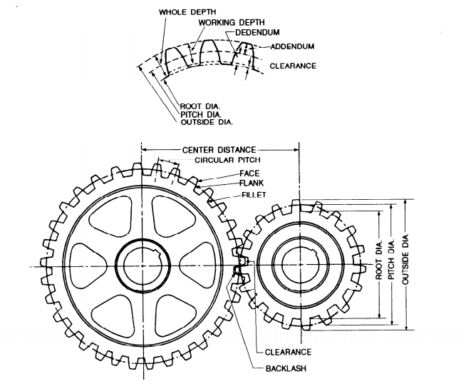

There are three classifications of helical springs: compression, extension, and torsion. Drawings seldom show a true presentation of the helical shape; instead, they usually show springs with straight lines.

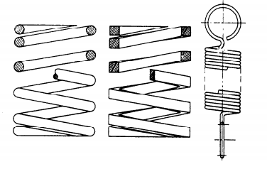

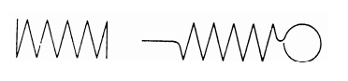

A modified symbol (check mark) with a number or numbers above it is used to show these surfaces and to specify the degree of finish.

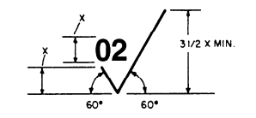

The number in the angle of the check mark, in this case 02, tells the machinist what degree of finish the surface should have.

Surface roughness symbol is drawn touching the line representing the surface. If space is limited, the symbol may be placed on an extension line on that surface or on the tail of a leader with an arrow touching that surface.

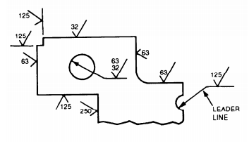

When a part is to be finished to the same roughness all over, a note on the drawing will include the direction “finish all over” along the finish mark and the proper number.

When a part is to be finished all over but a few surfaces vary in roughness, the surface roughness symbol number or numbers are applied to the lines representing these surfaces and a note on the drawing will include the surface roughness symbol for the rest of the surfaces.

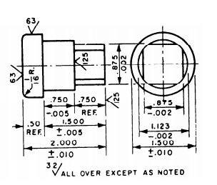

American industry has adopted a new standard, Geometrical Dimensioning and Tolerancing, ANSI Y14.5M-1982. This standard is used in all blueprint production whether the print is drawn by a human hand or by computer-aided drawing (CAD) equipment. It standardizes the production of prints.

Piping drawings show the size and location of pipes, fittings, and valves. A set of symbols has been developed to identify these features on drawings. Two methods of projection used in pipe drawings are orthographic and isometric (pictorial).

Single- and double-line orthographic pipe drawings are recommended for showing single pipes either straight or bent in one plane only.

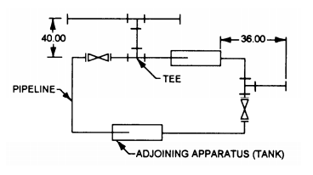

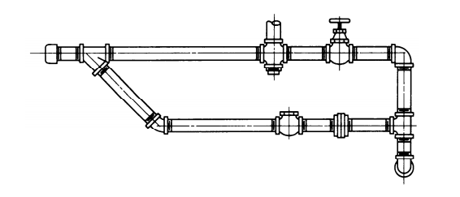

The crossing of pipes without connections is normally shown without interrupting the line representing the hidden line. When there is a need to show that one pipe must pass behind another, the line representing the pipe farthest from the viewer will be shown with a break, or interruption, where the other pipe passes in front of it.

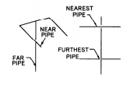

If standard symbols for fittings like tees, elbows, crossings, and so forth are not shown on a drawing, they are represented by a continuous line. The circular symbol for a tee or elbow may be used when it is necessary to show the piping coming toward or moving away from the viewer.

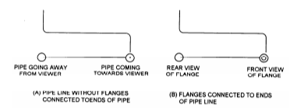

The below screenshots show some additional piping, valve, and connection symbols.

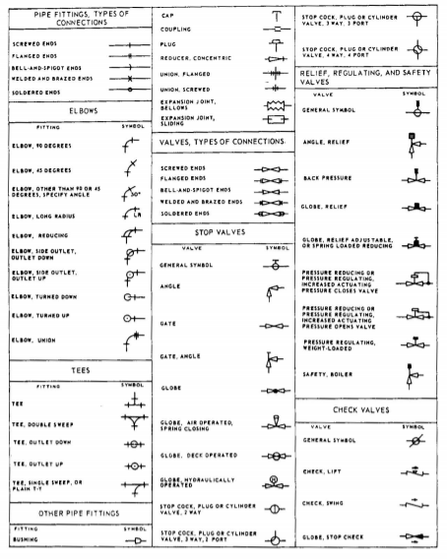

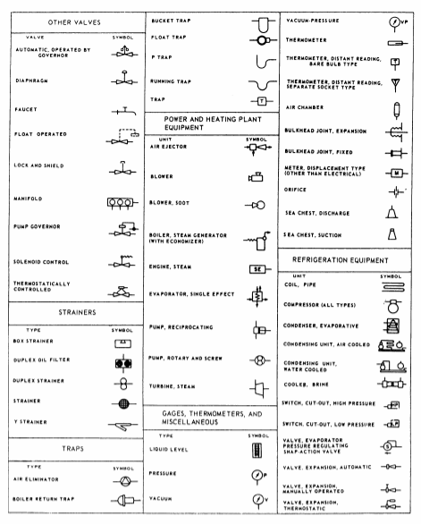

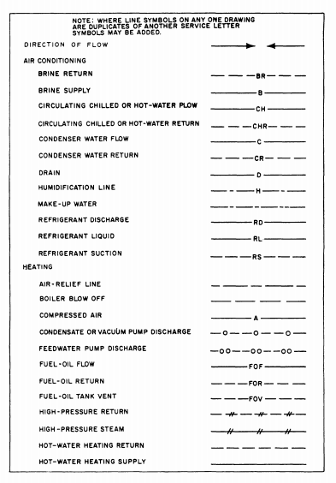

Different rules, or standards, apply for blueprints depending on who/why they are being drawn up. But a good rule is that colors are painted on valve wheels and pipe lines carrying hazardous fluids.

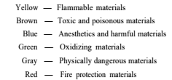

Some additional markings that may show on blueprints help to identify hazards. Again, blueprint standards may differ according to the organization or discipline they are being used in.

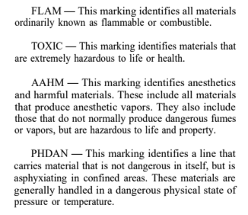

You may also encounter hydraulic symbols. These may include:

Supply Lines—These lines carry fluid from the reservoir to the pumps. They may be called suction lines.

Pressure Lines—These lines carry only pressure. They lead from the pumps to a pressure manifold, and from the pressure manifold to the various selector valves. Or, they may lead directly from the pump to the selector valve.

Operating Lines—These lines alternately carry pressure to, and return fluid from, an actuating unit. They also may be called working lines. Each line is identified according to its specific function.

Return Lines—These lines return fluid from any portion of the system to a reservoir.

Vent Lines—These lines carry excess fluid overboard or into another receptacle.

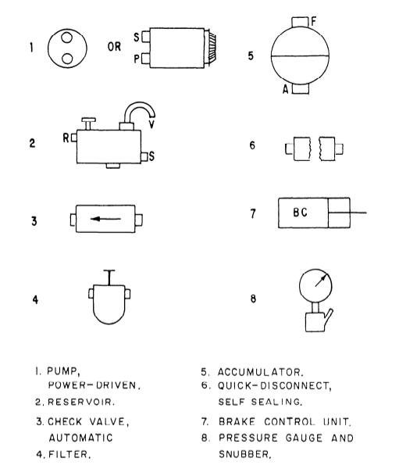

Lines and arrows are typically used in hydraulic blueprints to indicate direction of movment:

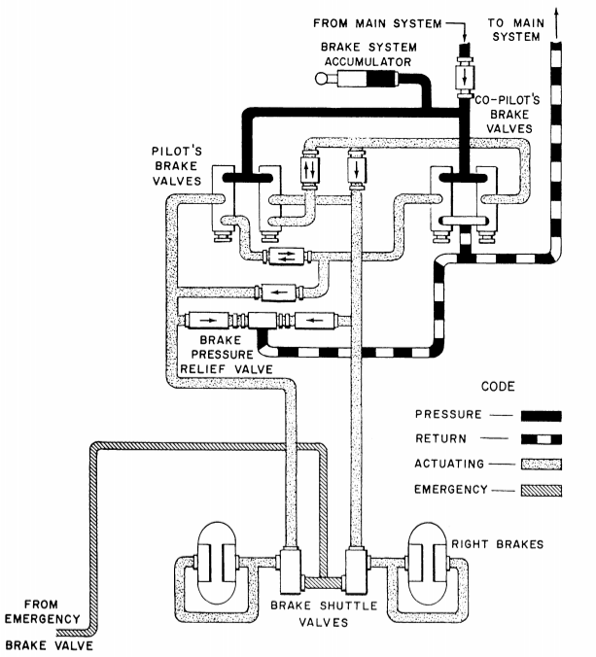

Plumbing prints may use some of the pipe symbols shown previously. However, there are others that may be used.

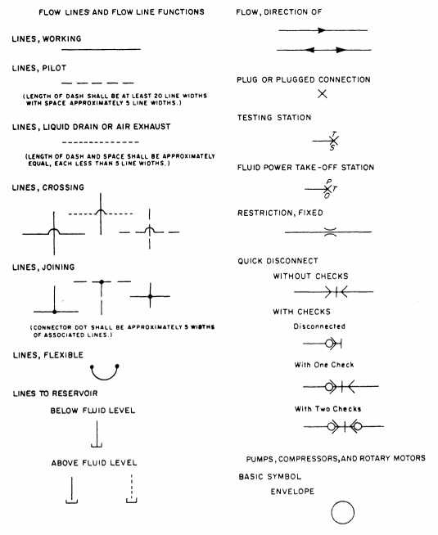

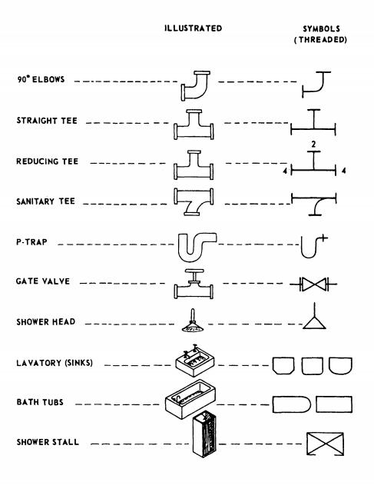

For fittings, remember that on crosses and elbows, you always read the largest opening first and then follow the alphabetical order. On tees, 45-degree Y-bends or laterals, and double-branch elbows, you always read the size of the largest opening of the run first, the opposite opening of the run second, and the outlet last.

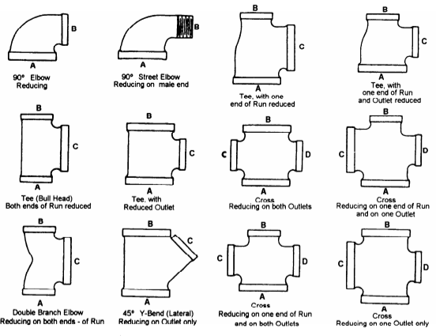

A pictorial wiring diagram is made up of pictorial sketches of the various parts of an item of equipment and the electrical connections between the parts.

An isometric wiring diagram shows the outline of a ship or aircraft or other structure, and the location of equipment such as panels, connection boxes, and cable runs.

A single-line diagram uses lines and graphic symbols to simplify complex circuits or systems.

A schematic diagram uses graphic symbols to show how a circuit functions electrically.

An elementary wiring diagram shows how each individual conductor is connected within the various connection boxes of an electrical circuit or system. It is sometimes used interchangeably with schematic diagram, especially a simplified schematic diagram.

In a block diagram, the major components of equipment or a system are represented by squares, rectangles, or other geometric figures, and the normal order of progression of a signal or current flow is represented by lines. An example of a block diagram is shown below.

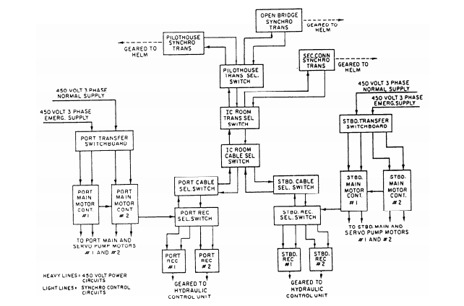

Electronics prints are similar to electrical prints, but they are usually more difficult to read because they represent more complex circuitry and systems.

Block diagrams that break down the simplified diagram into enough detail to show a fairly detailed picture of functional operation, but do not include wave forms, test points, and so on, are usually called functional block diagrams.

A detailed schematic diagram shows detailed information about circuits and parts and must be used in conjunction with a detailed block diagram to effectively troubleshoot a system.

A reference designation is a combination of letters and numbers used to identify the various parts and components on electronic drawings, diagrams, parts lists, and so on. The prints you work with will have one of two systems of reference designations. The old one is called a block numbering system and is no longer in use. The current one is called a unit numbering system. In that reference designation system, electronic systems are broken into sets, units, assemblies, subassemblies, and parts. A system is defined as two or more sets and other assemblies, subassemblies, and parts necessary to perform an operational function or functions.

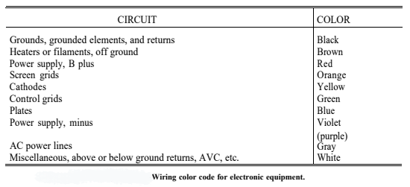

A set is defined as one or more units and the necessary assemblies, subassemblies, and parts connected or associated together to perform an operational function.

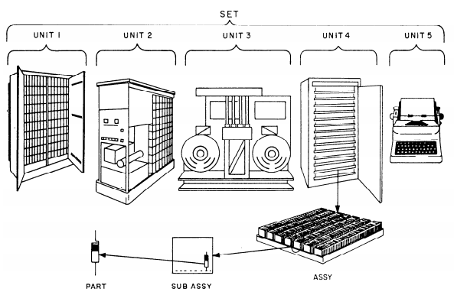

Reference designations are typically assigned beginning with the unit and continuing down to the lowest level (parts).

Units are usually assigned a number beginning with 1 and continuing with consecutive numbers for all units of the set. This number is the complete reference designation for the unit. If there is only one unit, the unit number is omitted.

Assemblies and subassemblies are typically assigned reference designations consisting of the unit number that identifies the unit of which the assembly or subassembly is a part, the letter A indicating an assembly or subassembly, and a number identifying the specific assembly or subassembly.

Parts are often assigned reference designations that consist of the unit and assembly or subassembly designation, plus a letter or letters identifying the class to which the part belongs (as in the block numbering system), and a number identifying the specific part.

For each additional subassembly, an additional letter A and number are added to the part reference designation.

On electronic diagrams, the usual procedure is to use partial (abbreviated) reference designations. In this procedure, only the letter and number identifying the part is shown on the part itself, while the reference designation prefix appears at some other place on the diagram. For the complete reference designation, the designation prefix precedes the partial designation.

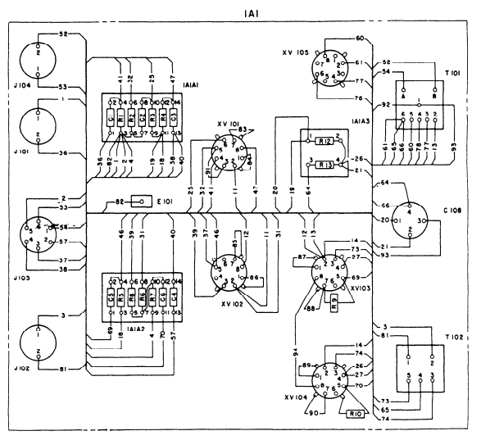

Interconnection diagrams show the cabling between electronic units and how the units are interconnected.

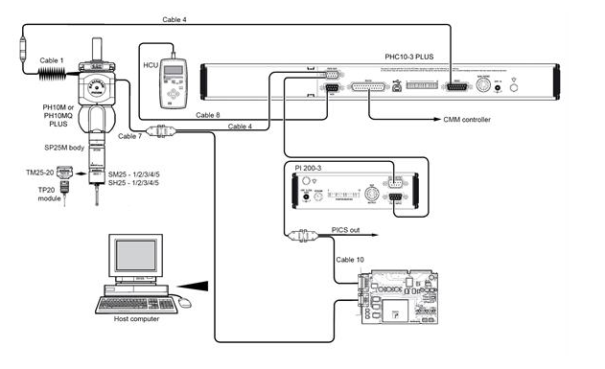

Individual conductors connecting to terminal boards are tagged with a vinyl sleeving called spaghetti that shows the terminal board and terminal to which the outer end of the conductor is connected.

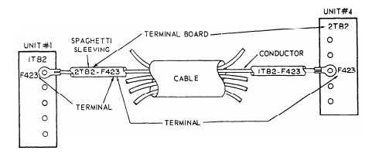

Electromechanical devices such as synchros, gyros, accelerometers, autotune systems, an analog computing element are quite common. You need more than an electrical or electronic drawing to understand these systems adequately; therefore, we use a combination drawing called an electromechanical drawing. These drawings are usually simplified both electrically and mechanically, and show only those items essential to the operation.

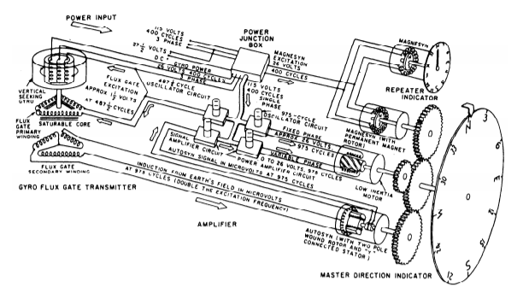

Digital computers are used to make logic decisions about matters that can be decided logically.

People use many logical truths in everyday life without realizing it. Most of the simple logical patterns are distinguished by words such as and, or, not, if, else, and then. Once the verbal reasoning process has been completed and results put into statements, the basic laws of logic can be used to evaluate the process. Although simple logic operations can be performed by manipulating verbal statements, the structure of more complex relationships can more usefully be represented by symbols. Thus, the operations are expressed in what is known as symbolic logic developed by George Boole.

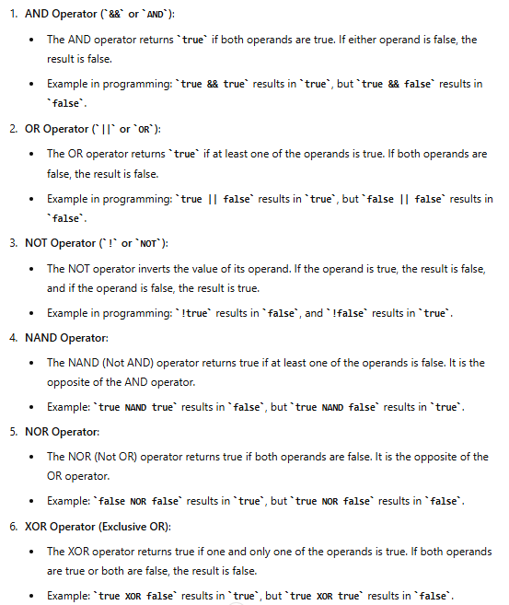

Truth tables are often used to represent the outcomes of logical operators. Here is a truth table for the AND operator:

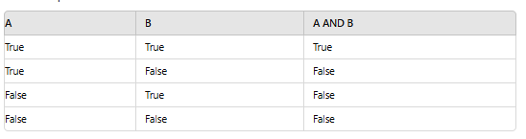

Basic logic diagrams are used to show the operation of a particular unit or component. Basic logic symbols are shown in their proper relationship so as to show operation only in the most simplified form possible.

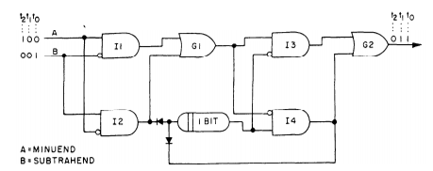

Detailed logic diagrams show all logic functions of the equipment concerned. In addition, they also include such information as socket locations, pin numbers, and test points to help in troubleshooting.

